###### K.L.E TECHNOLOGICAL UNIVERSITY,

**HUBLI- 580031**



**A Course Project on Internet of Things**

**Report**

**On**

**INTELLIGENT AND WEATHER ADAPTIVE SMART STREETLIGHT SYSTEM**

*submitted in partial fulfillment of the requirement for the degree of*

**Bachelor of Engineering in**

**Computer Science and Engineering**

**Submitted By**

**SHOURYA** (01FE20BCS316) - 556  
**AKASH ARYAN** (01FE20BCS283) - 523  
**NITIN KUMAR** (01FE20BCS301) - 538  
**SHUBHAM KUMAR** (01FE20BCS269) - 518  
**VAIBHAV KUMAR** (01FE20BCS255) - 513

**Under the guidance of**

**Prof. MEENAXI RAIKAR**

Department of Computer Science and Engineering

K.L.E. TECHNOLOGICAL UNIVERSITY

HUBLI – 580031 (India).

**INTRODUCTION: -**

IoT is a network of physical devices that allows devices to communicate with each other. IoT enables remote sensing and device control. It is an advanced automation and analysis system that uses artificial intelligence technology to provide advanced and automated products and services. These systems allow for more transparency, better control, and good performance. IoT has several automation applications such as smart home, smart parking, smart road, smart lighting, etc. Current manual street lighting system has many problems such as maintenance problems, timing problems and connectivity problems. These problems can be solved by IoT technology.

The system is based on an intelligent public lighting system and management that automatically adapts to weather conditions. Automation simplifies various concerns in the global economy as well as in everyday life. It uses the latest LED technology as a light source to restore ordinary street lamps such as HID or high-pressure sodium lamps, etc. LEDs are used for a variety of advantages over existing technologies, such as energy savings due to increased current luminous efficiency, lower maintenance costs, high color rendering index, faster Easy starting and durability. Today, the versatility of public lighting is hotly contested. The majority of commands run in manual configuration, while some are automated based on the settings around them. Managing location in a remote area is the biggest dilemma. Manual errors can waste energy and reduce system performance.

The focus of this article is on automating streetlights to increase system productivity and accuracy in a cost-effective way, while enabling wireless access and system control. The main driver of the system is energy conservation because the resources such as hydroelectricity, thermal power and coal that we rely on are not easily replenished. necessary, needs. The relay is used as an automatic switch and reduces manual labor by almost 100%. The main problem of the current electrical system is the connection problem because most of the connections handled by different contractors are done manually. Timer setting is done manually. Timers typically require twelve hours of continuous power, and other timer settings can be disturbed when there is no uninterruptible power. It supports a client-server mechanism where a single user can control the entire system. It reduces heat and carbon dioxide emissions. IOT-based street light automation is a cost-effective and environmentally friendly method, while eliminating the problems of disposing of incandescent lamps and saving energy.

**PROBLEM STATEMENT: -**

* To design and implement an automated street lighting system utilizing the basic principles of IOT which will be responsive towards weather conditions and day light intensity.

**LITERATURE SURVEY: -**

1. **Application of Intelligent Lighting Control for Street Lighting System**

**[Tra2n Phuong Nam, Nguyen Van Doai]**

• In this study, the public lighting system was studied and aimed at

• Focus on innovative products and components for public lighting

• Proposing solutions to reduce electricity consumption based on intelligent remote control and measurement systems using GPS/GPRS/4G technology for public lighting.

1. **Research of Intelligent Street Light System Based on ZigBee [Zhixiong Ke, Chun Xiao]**

• Introduced wireless public lighting control system based on ZigBee network.

• It realizes on/off control, power regulation and fault monitoring by adopting ZigBee wireless technology.

1. **Experimental Research on Light and Energy Parameters of Intelligent Street and Road Lighting Systems [Valentin Gyurov, Hristian Panchev]**

• The report presents research on testing the lighting energy and specifications of smart street and street lighting systems in the city of Varna, Bulgaria.

• Energy efficiency analysis was performed according to the parameters described in the Bulgarian National Standard (BDS) EN13201-5, quantifying the estimated values ​​and allowing comparison with other design solutions for other establishments.

1. **Autonomous Intelligent Control for LED Street Lighting [Ivan Angelov, Peter Stoev]**

• An intelligent standalone controller for dimmable LEDs has been developed.

• A group of street lights, for a street, a county or a village, switched on and off by an ephemeris relay.

• Each luminaire has a small control system with the ability to automatically adjust intelligently during luminaire operation.

• When in operation, the luminous flux of the lamp grows according to a certain algorithm and corrects the aging of the source according to the cumulative working hours.

1. **Energy Efficient Smart Street Lighting System in Nagpur Smart City using IoT –A Case Study [Ruchika Prasad]**

• Street lighting is an important factor in ensuring safety in the city and creating a sense of security in people's minds.

• Smart street lighting is a cost-effective solution in urban environments without compromising on advanced wireless communication techniques, low-cost LEDs and additional intensity control sensors the light.

• Smart lighting case study in Nagpur smart city, where one of the goals is to reduce carbon footprint by reducing energy consumption. This is achieved by replacing 320 obsolete street lights and integrating 63 more LEDs with an intelligent motion sensor lighting system.

**OBJECTIVES: -**

The main objectives of the street lighting system are:-

* Motion Detection Light Control
* Fault Detection for faster reports to authorities
* Street surroundings data collection algorithm

**SOFTWARE REQUIREMENTS: -**

* Blynk IoT: - To send and receive data over the cloud and mobile application.
* Arduino IDE: - To dumb the code into the node MCU.

**CIRCUIT DIAGRAM: -**

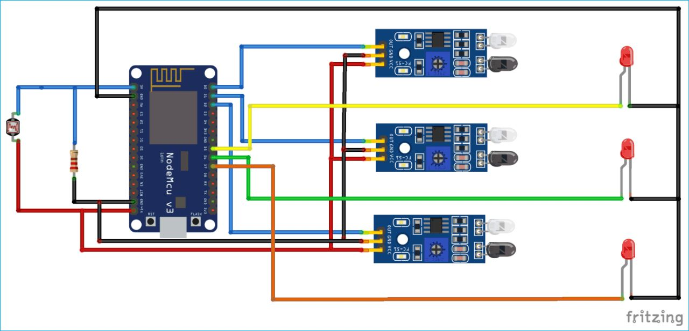

**HARDWARE REQUIREMENTS: -**

* LDR Sensor



* IR Sensor



* LED Lights



* Microprocessor ESP32 / ESP8266

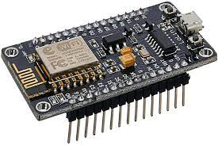

**COST ESTIMATION OF HARDWARE COMPONENTS: -**

|  |  |  |
| --- | --- | --- |
| **Component** | **Quantity** | **Price(Rs.)** |
| **ESP8266 MCU** | **1** | **275** |
| **LED lights** | **4** | **40** |
| **IR Sensors** | **4** | **100** |
| **LDR Sensor** | **1** | **8** |
| **Jumper wires (MALE TO MALE)** | **10** | **30** |
| **Jumper wires (MALE TO FEMALE)** | **10** | **30** |
| **Single Strand Wire** | **1** | **40** |
| **Battery 9V** | **4** | **149** |
| **12V Adapter** | **1** | **240** |
| **Resistors** | **4** | **50** |
|  | **TOTAL** | **Rs. 962** |

**FUNCTIONAL REQUIREMENTS: -**

* The system shall be able to control the street lights remotely.
* The system should report the error in case of any street light failure.
* The system should detect the motion of vehicles passing and respond accordingly.
* The system should automatically turn on the street lights when daylight intensity lowers a particular value.

**PROPOSED SYSTEM: -**

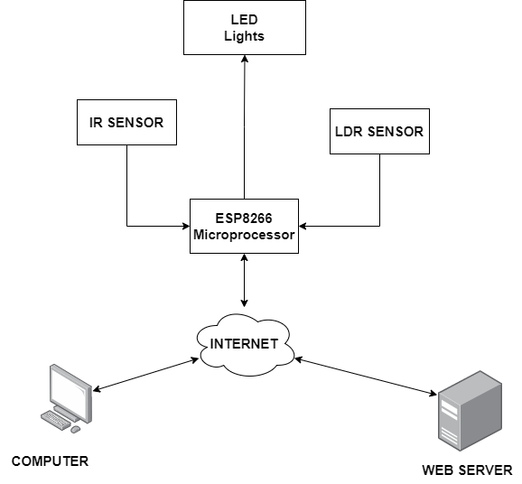

**IMPLEMENTATION -**

***Server side***

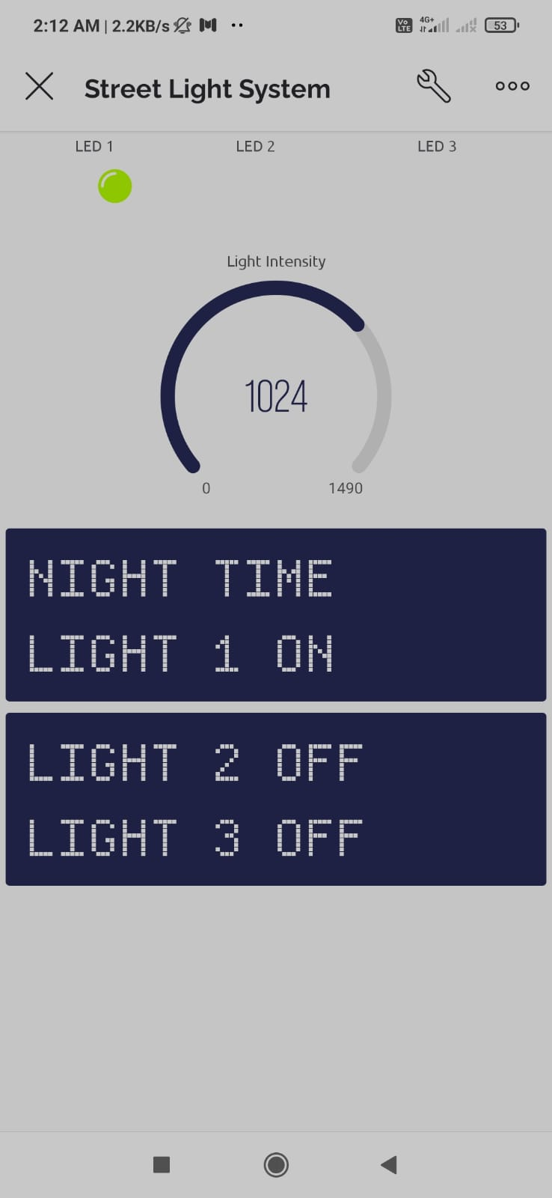

This is an application for the communication between the control room and the blynk cloud. It is made using BlynkIoT application. This shows the status of the streetlight in action according to the available light intensity and detects presence of vehicle and responds accordingly. The application uses a centralized cloud server for the storage of data. The application uses internet services to send and receive data over Wi-Fi.

***Clients side***

The Client side has the following code dumped to the NODE MCU. The Node MCU has built in Wi-Fi module to connect to internet and send it to the mobile application.

Here are the some of the important snippets of the dumped code.

*#define BLYNK_TEMPLATE_ID "**********"*

*#define BLYNK_DEVICE_NAME "Street Light System"*

*#define BLYNK_PRINT Serial*

*#include <ESP8266WiFi.h>*

*#include <BlynkSimpleEsp8266.h>*

*char auth[] = "4zY-xJ5KZxq-**************";*

*char ssid[] = "******";*

*char pass[] = "*********";*

*int ledpin3 = D7;*

*int ledpin2 = D6;*

*int ledpin1 = D5; defining the pins*

*int irsensor1 = D0;*

*int irsensor2 = D1;*

*int irsensor3 = D2;*

*int ldr = A0;*

*int valuel;*

*WidgetLED Led1(V0);// Virtual Pin V0*

*WidgetLED LED2(V1);// Virtual Pin V1*

*WidgetLED LED3(V2);// Virtual Pin V2 snippets to connect*

*WidgetLCD lcd(V7); application*

*WidgetLCD lcd1(V8);*

*BlynkTimer timer;*

*void readl(){*

*valuel = analogRead(ldr);*

*Blynk.virtualWrite(V3,valuel);*

*}*

*void sensor1(){*

*int value = digitalRead(irsensor1);*

*int value2 = digitalRead(irsensor2);*

*int value3 = digitalRead(irsensor3);*

*valuel = analogRead(ldr) function to*

*if(valuel>=800) control lights*

*{*

*lcd.print(0,0,"NIGHT TIME");*

*if(value == LOW){*

*Led1.on();*

*digitalWrite(ledpin1,HIGH);*

*lcd.print(0,1,"LIGHT 1 ON ");*

*}*

*else{*

*Led1.off();*

*digitalWrite(ledpin1,LOW);*

*lcd.print(0,1,"LIGHT 1 OFF");*

*}*

*void setup()*

*{*

*pinMode(ledpin1,OUTPUT);*

*pinMode(ledpin2,OUTPUT);*

*pinMode(ledpin3,OUTPUT);*

*pinMode(irsensor1,INPUT);*

*pinMode(irsensor2,INPUT);*

*pinMode(irsensor3,INPUT);*

*Serial.begin(9600);*

*Blynk.begin(auth, ssid, pass);*

*timer.setInterval(300L,sensor1);*

*timer.setInterval(300L,readl);*

*}*

*void loop()*

*{*

*Blynk.run();*

*timer.run();*

*}*

**RESULT ANALYSIS: -**

The project aims were to reduce the side effects of the current lighting system and find a Solution to save power. In this project the first thing to do is to prepare the inputs and outputs of the system to control the lights. The project shown in the figure has been implemented and works as expected and will prove to be very useful. The prototype of the system with obstacle detection on the street through IR sensor where the IR Sensor detects the obstacle and switch ON the Lights.

Thanks to this system, the elements of negligence can be avoided by operator uses sunset and sunrise time confirm to turn the street light on and off. the excellence of LEDs and the engineering of dimming the light by intensity provides 25-30% more power economy. Therefore, it is best suited for upcoming smart cities in India. These cost savings can also enable municipalities to expand street lighting to additional areas, increasing access to lighting other low-income and underserved areas. Deployment of the system in sub-rural areas of Indian area is possible due to compact and independent design control action. Therefore, even if one comes from a non-technical background, once this system is fitted on the site, it works without any error.

**CONCLUSION:**

This paper proposes a street lighting management system consisting of one Web-based cloud management platform and could be a price effective, eco-friendly and therefore the safest technique to save energy and through this method the light status data is accessed from anytime and anywhere. It clearly tackles the matter and the planet is facing these days that’s, saving energy. The project has scope in varies alternative applications like for providing lighting in industries, campuses and parking lots of large spaces like malls.

**REFERENCES:**

* [1] Elejoste P, Angulo I, Perallos A, Chertudi A, Zuazola IJ, Moreno A, Azpilicueta L, Astrain JJ, Falcone F, Villadangos J. An easy to deploy street light control system based on wireless communication and LED technology. Sensors. 2019 May 16;13(5):6492-523.
* [2] Sung, Wen-Tsai, and Jia-Syun Lin. "Design and implementation of a smart LED lighting system using a self-adaptive weighted data fusion algorithm." Sensors 2018, Dec 6;13(12):16915-39.
* [3] Escolar, S., Carretero, J., Marinescu, M.C. and Chessa, S., Estimating energy savings in smart street lighting by using an adaptive control system. International Journal of Distributed Sensor Networks. 2020
* [4] Mohamed SA. Smart street lighting control and monitoring system for electrical power saving by using VANET. Int'l J. of Communications, Network and System Sciences. 2020 Jul 26;6(08):351.
* [5] Müllner R, Riener A. An energy efficient pedestrian aware Smart Street Lighting system. International Journal of Pervasive Computing and Communications. 2017 Jun 28;7(2):147-161.
* [6] Pizzuti S, Annunziato M, Moretti F. Smart Street lighting management. Energy Efficiency. 2019 Aug 1;6(3):607-616.
* [7] Rajput KY, Khatav G, Pujari M, Yadav P. Intelligent Street lighting system using gsm. International Journal of Engineering Science Invention. 2013 Mar;2(3):60-9.
* [8] Yusoff YM, Rosli R, Karnaluddin MU, Samad M. Towards smart street lighting system in Malaysia. InWireless Technology and Applications (ISWTA), 2018 IEEE Symposium on 2018 Sep 22 (pp. 301-305). IEEE.
* [9] B. Abinaya, S. Gurupriya, and M. Pooja, IoT Based ASED Smart and Adaptive Lighting in Street Lights. Second International Conference on Computing and Communications Technologies (ICCCT17), 2017.
* [10] Lakshmana Phaneen manguluri, Yashwanth Sri Venkatesh sorapalli, Lokesh kumar Nakkala, and Venkat Tallari,Smart Street Lights Using IoT, International conference on applied and Theoretical Computing and Communication Technology,2017.
* [11] M. Kokilavani, and A. Malathi, Smart Street Lighting System using IoT, International Journal of Advanced Research in Applied Science and Technology, Vol.3, No.11, 2017.
* [12] Parkash, Prabu V, and Dandu Rajendra, Internet of Things Based Intelligent Street Lighting System for Smart City. International Journal of Innovative Research in Science, Engineering and Technology, Vol. 5, No. 5, 2016, pp. 7685- 7691.